|  |  |  |  |
| --- | --- | --- | --- |
| Task | | Hours | Note |
| Product page | Adding short description | 4 |  |
|  | Add starting price | 2 |  |
|  | Show how many color | 2 |  |
| Product quote page | Make small picture | 2 |  |
|  | Remove unit price | 1 |  |
|  | Remove related products | 1 |  |
|  | Remove start order button | 1 |  |
|  | Replace start designing | 1 |  |
|  | Edit layout for product detail | 10 |  |
| Design studio | Product G5000 as default | 4 |  |
|  | Fix bug Add text | 0 |  |
|  | Add function change order layer | 4 |  |
| Backend |  |  |  |
| Add order | Create new layout to add customer information | 10 |  |
|  | Create new function for add manualy customer info | 8 |  |
|  | Add and edit shipping date | 4 |  |
|  | Create new function for edit (Change quality, change color, update new price ) item in order | 20 |  |
|  | Create new function add more item into order | 20 |  |
| Edit item | Create edit function for shipping option | 10 |  |
|  | Edit price with new discout function | 10 |  |
|  | Edit payment method | 10 |  |
|  | Add new line for Deposit | 10 |  |

Product Page:

* Adding description under product name (light font)
* Adding “starting $x.xx”
* - Showing how many colors available

(EXAMPLES images below – DO NOT COPY)

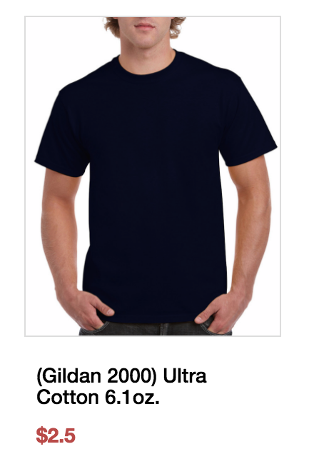

Product quote page:

* picture is too big (it should be much smaller) (<http://teevisionprinting.com/product/1-Ultra-Cotton-610z>)
* remove unit price above related products
* -remove related products images
* remove start order button and replace start designing (different color)
* able to add page description in middle of page. Below on right side is Product descrption on left side & size chart on the right side (example below do not copy) (<https://www.rushordertees.com/G200/>)
* 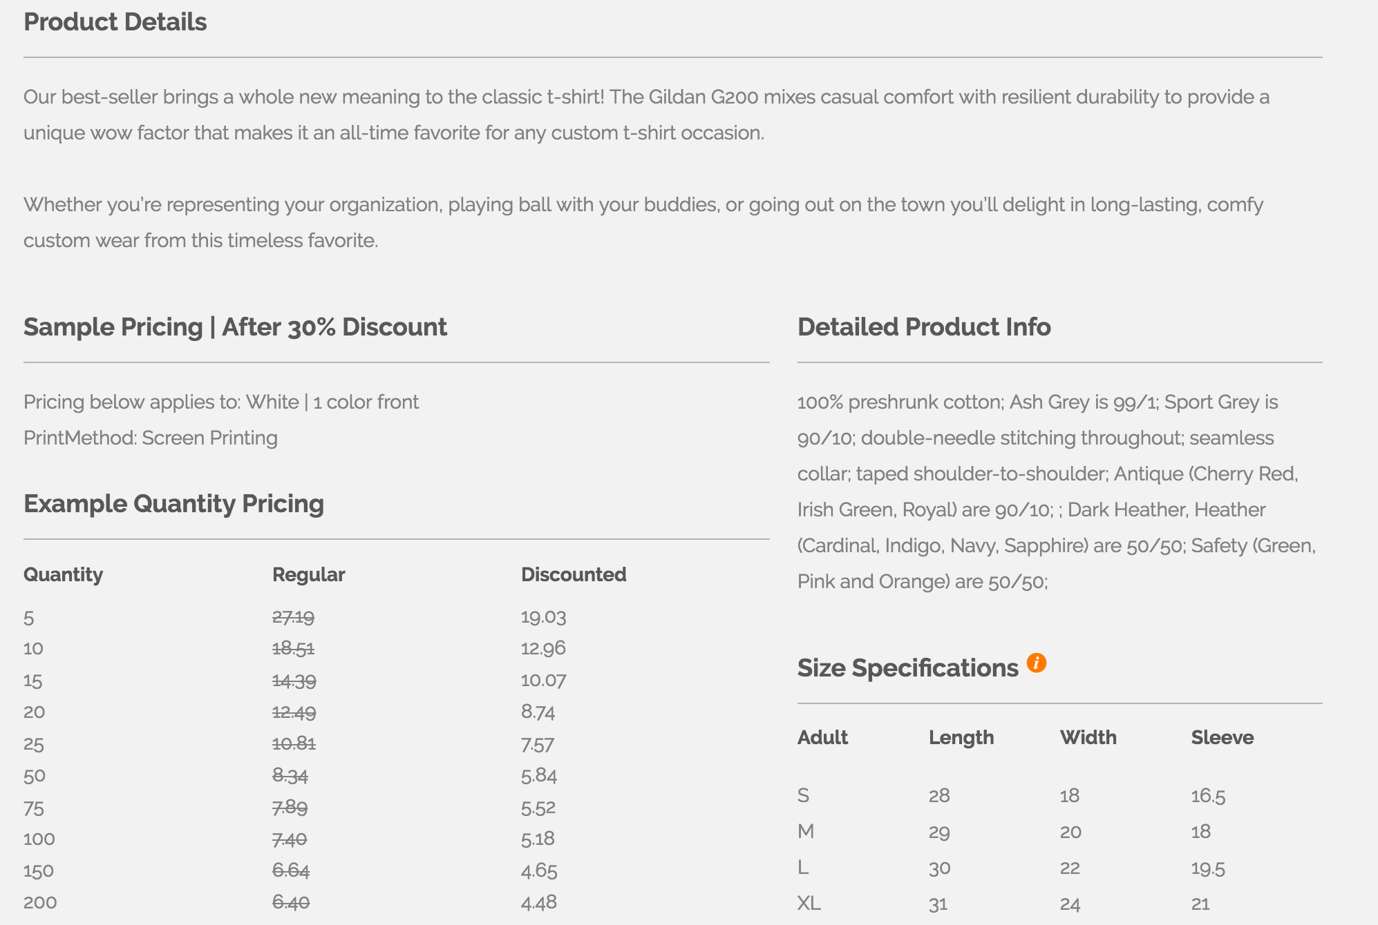

DESIGN STUDIO: having product G5000 as default with product color list window. 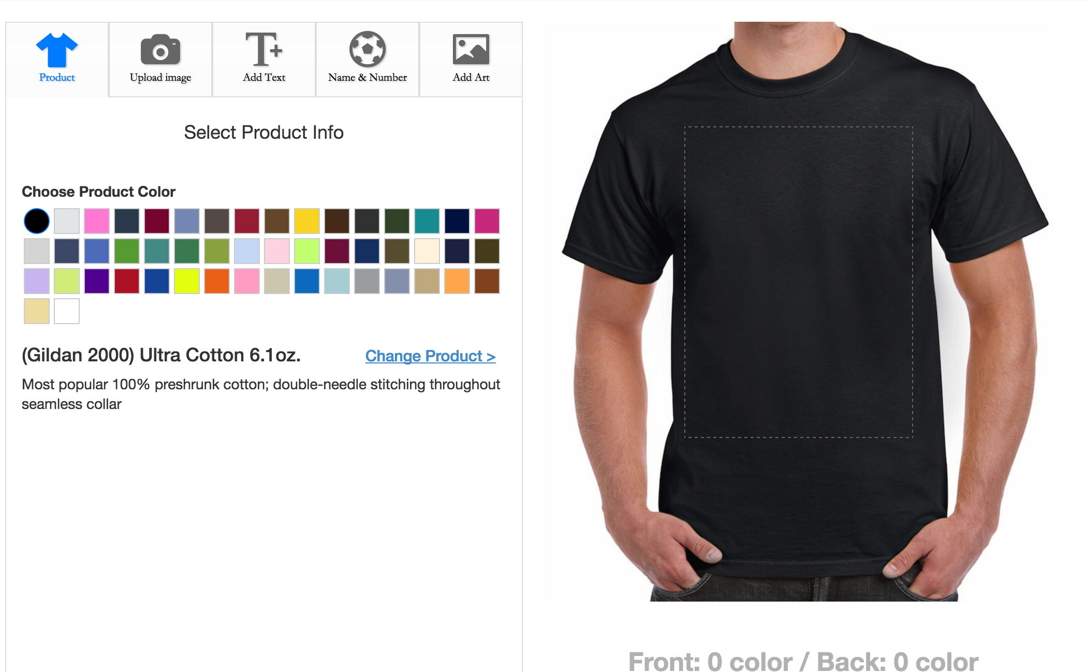

FIXING BUG: TEXT disappears on screen when it is added. It reappears when you click the text on the shirt to “change the words” (so if you want add another text it would make user do it easier)

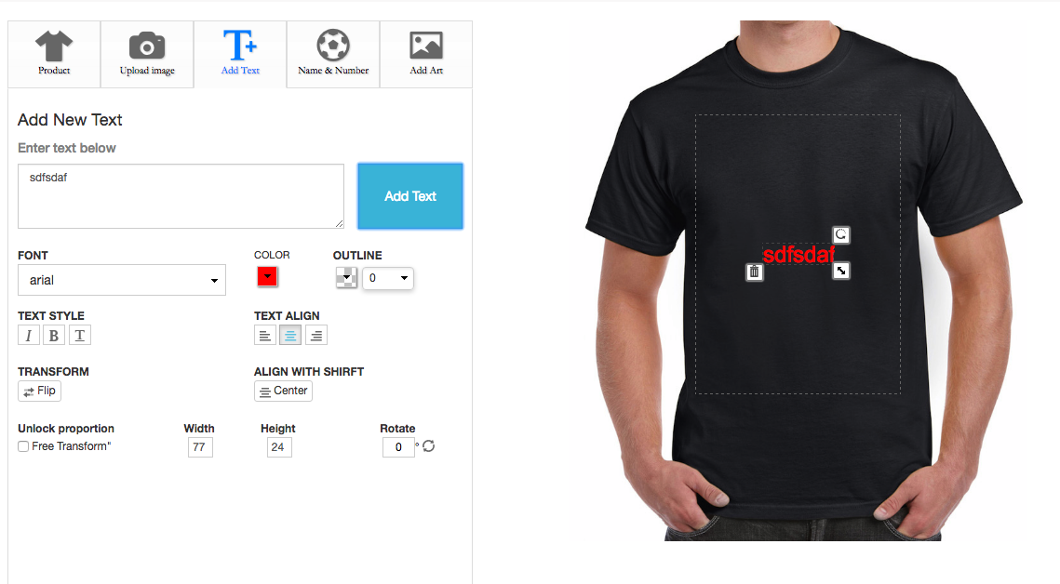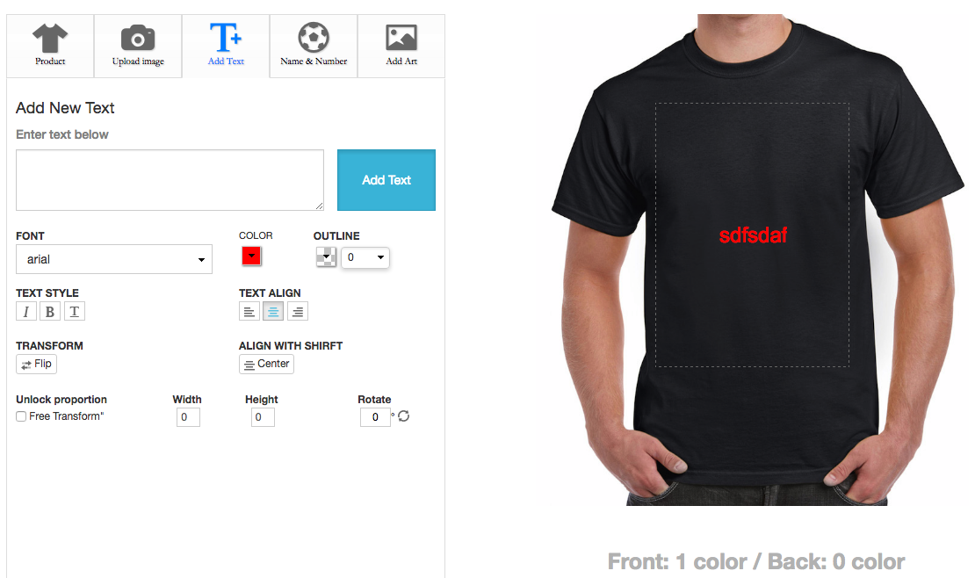

FIXING BUG: Being able to move text or logo in front or make of layer.

BACKEND WORK

Adding Orders manually into schedule and order list.

Button on Dash Board “Add Order”

STEPS:

* Filling out Customer Information: (address, phone number, and email ((not required information))
* Ship Date
* Able to change, and add or delete a line on product description.
* Changing Product and adding a Line of products

(This adds a new line to the bottom description)

****** This adds into the schedule list********

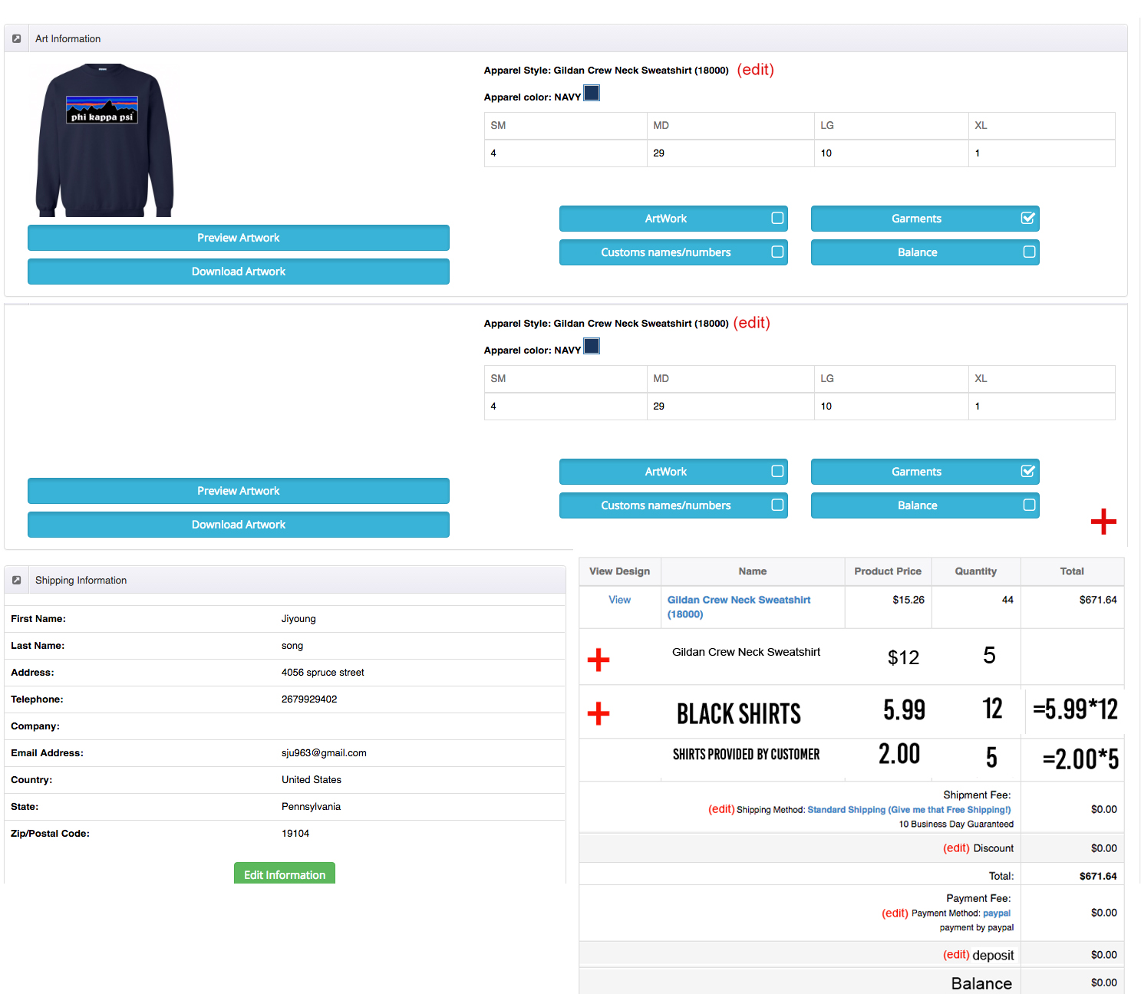

(EDIT LINES)

Shipping: Drop down menu with different shipping options

Discount: Able to input number and/or percentage of total

Payment: Drop Down menu of option of “Cash, check, or credit card”

* if they input Credit card it will take you to paypal payment window to pay the amount of they wish (option of total price or portion payment)
* Deposit: Shows how much payment was accepted of the payment total

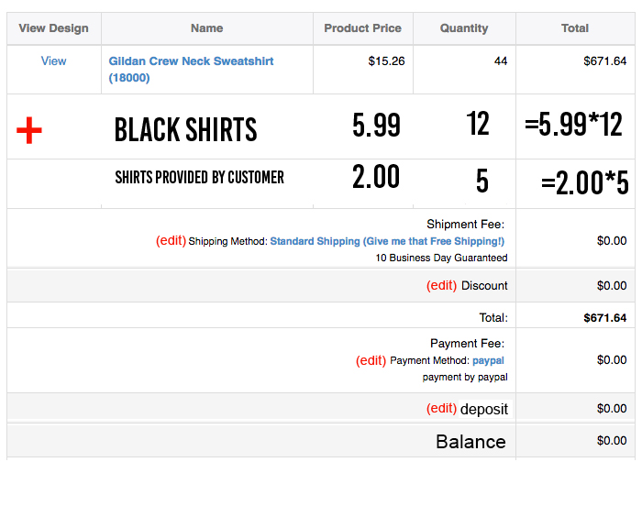

Creating Quote/Invoice